Dear Friends, you are cordially invited to the

Twenty Club & Innominate Club
Annual Burns Night Supper

Friday 23rd January 2026
Liverpool Medical Institution

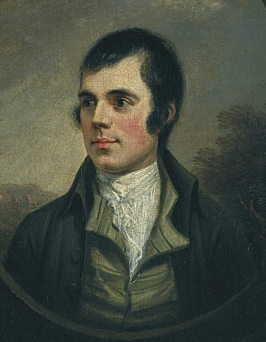

RSVP by 15th January 2026

Prof Dan Cuthbertson
(President XX Club)

